### An analytical approach for predicting used BMW car price based on the presence of certain used car data

**Prof: Dr. Balu Gokaraju**

**Student: Nikita Agarwal**

**Problem Description**

**Introduction:**

The ones who think to sell their cars always think about their car’s second-hand market worth, at first. Both for the sellers and the buyers, it is crucially important to estimate the car’s realistic worth, in order not to suffer a loss of money or time. In this project, we are considering used BMW cars. BMW is one of the largest car manufacturers in the world and currently hold the largest market share worldwide. It has wide range of model from MPV to sports car where the price range is also varied.

**Goals of the project are as follows:**

* When is the ideal time to sell certain cars (i.e., at what age and mileage are there significant drops in resale value)
* To find the price of car changes over the years.
* To find which transmission models of the cars are sold the most.
* To find which car model stands first in sales.
* We are also interested in identifying those vehicle attributes that are responsible for retaining the car’s value in the used car market.

**Attribute information:**

This data set is collected from used cars in UK. The data set contains information of price, transmission, mileage, fuel type, road tax, miles per gallon (mpg), and engine size. This is a regression problem.

* Dependent variable: price
* Independent variables: model, year, transmission, mileage, fuel type, tax, miles per gallon, engine size.

**Below is more information about the dataset:**

* Dataset Title: 1000,000 UK used car dataset
* Number of Instances: 10782
* Number of Attributes: 9

**Dataset:**

The main priority for searching the suitable dataset was to choose one that includes important features that can affect the price of used cars.

The Kaggle dataset used for the project is “100,000 UK Used Car Dataset”.

<https://www.kaggle.com/adityadesai13/used-car-dataset-ford-and-mercedes?select=bmw.csv>

**Programming language:**

Based on the availability of rich analytical packages (Pandas/Matplotlib) for Python, it will be the primary language for this project. I will also use TensorFlow and SciKit Learn to apply machine learning model

**Process Block Diagram:**

Feature Tuning

Training

Dataset from Kaggle

kaKa

Compare Predictive Models A/B/C

Preprocessing Extraction Normalization

Predictive Model

Validation

**Preprocessing of Dataset:**

After having gathered the dataset, the data preprocessing on the car producers datasets has been performed. The first step was to investigate the structure of the car producers’ datasets, looking at its shape and at the type of variables included. Functions like head(), shape, describe(), info, and, dtypes were used to investigate them. Most of the independent variables were string, integer and float data types.

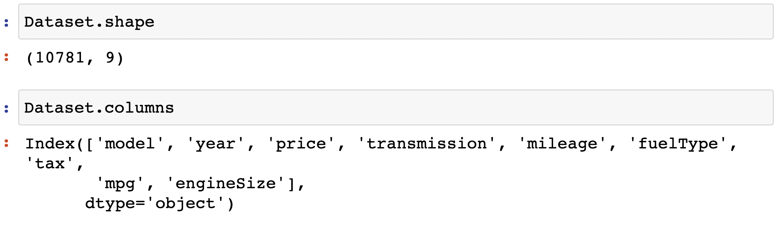

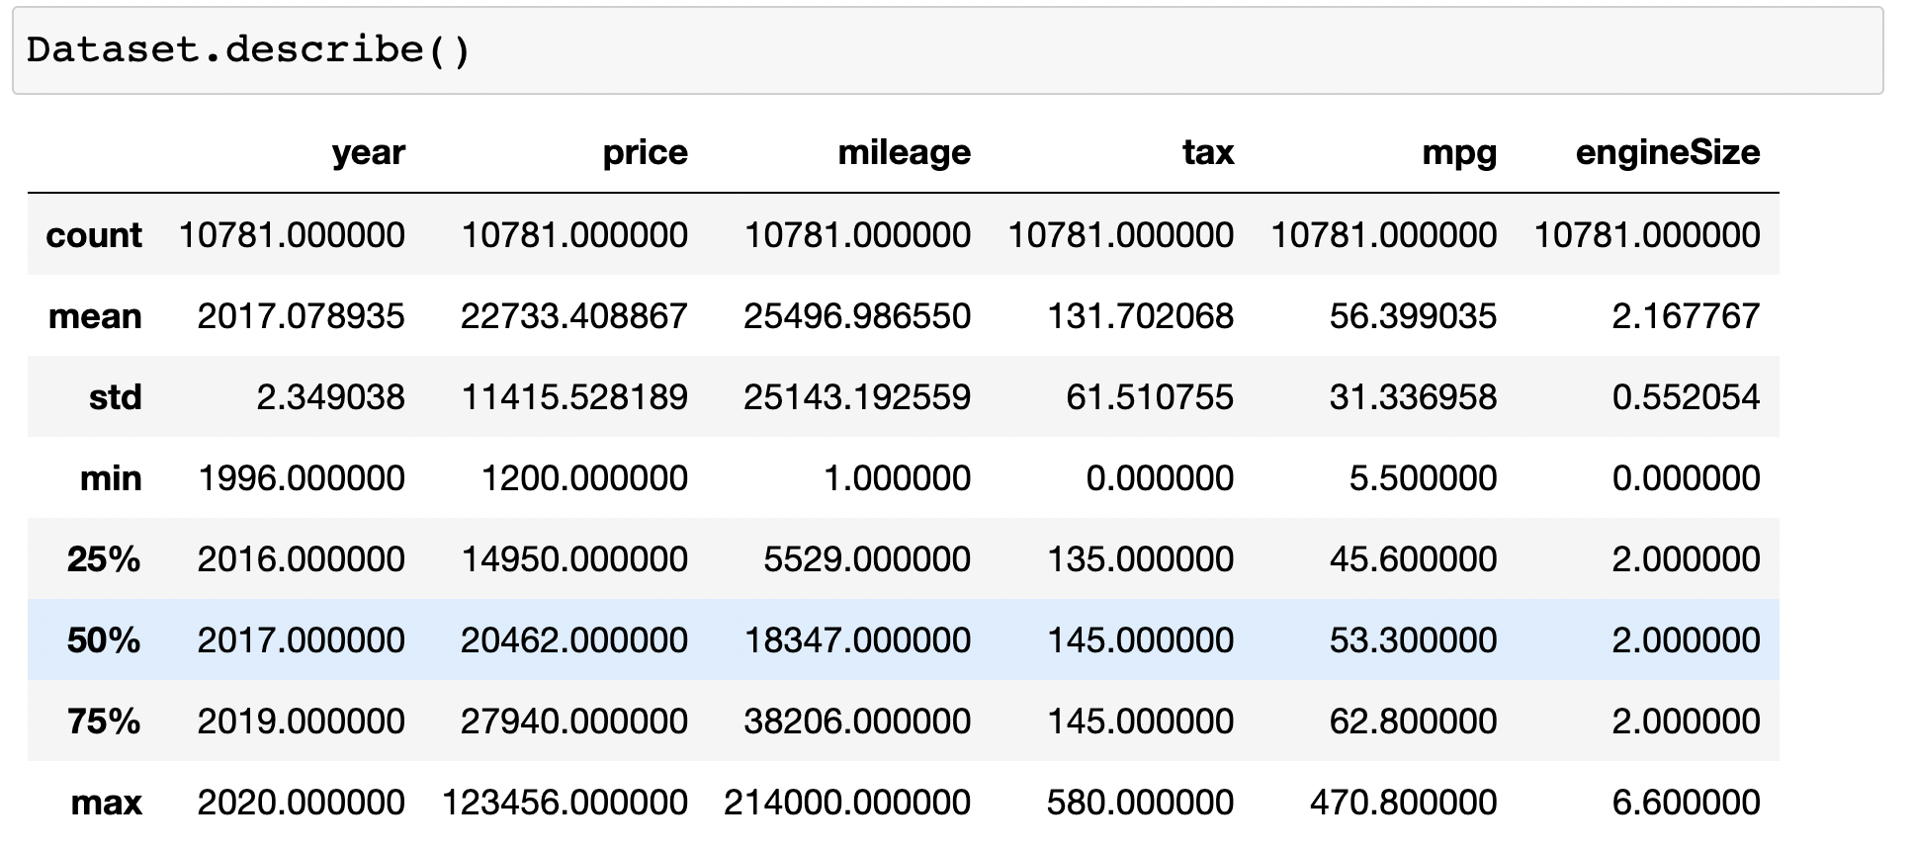

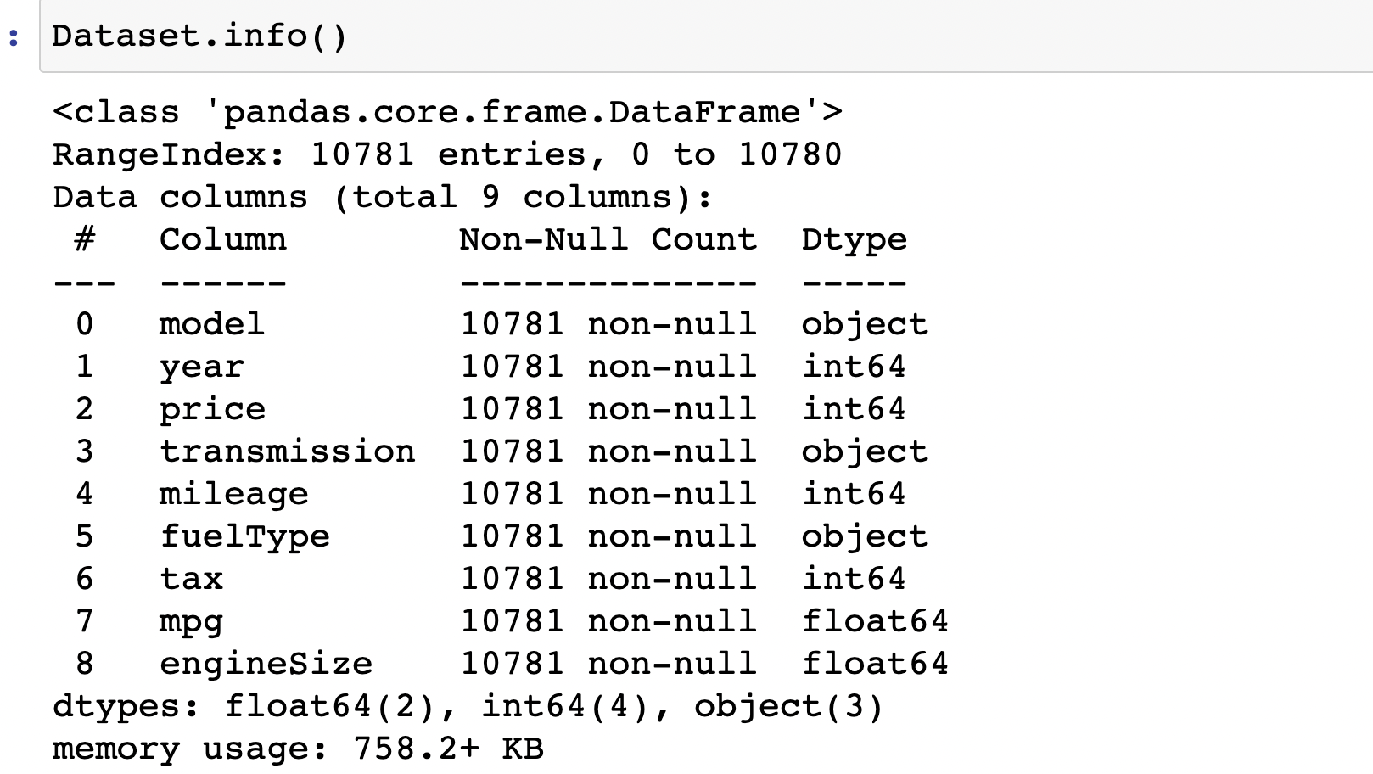

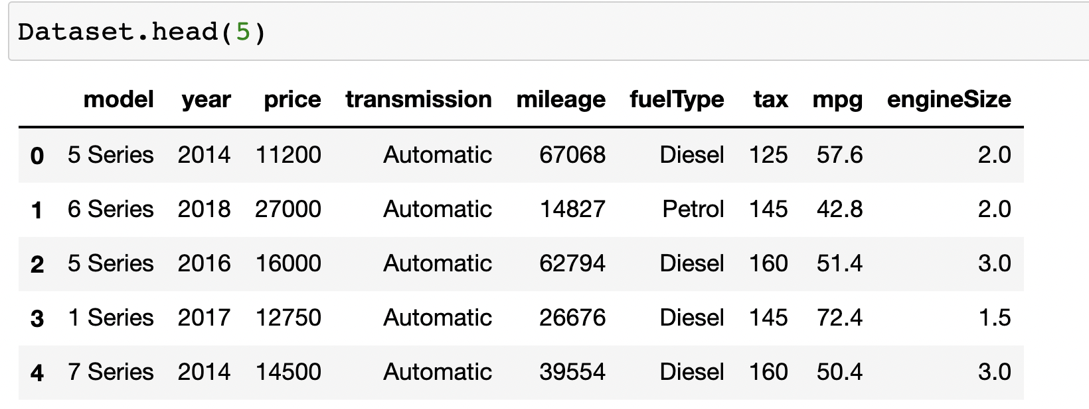

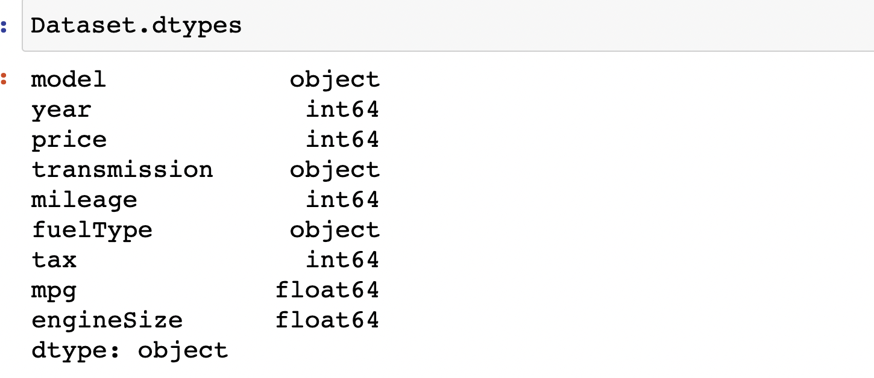

### There were 5 numerical columns, 3 categorical columns and 1 year column. Three categorical columns are as follows: Model, Transmission and Fuel type and now we need to check Distinct BMW-Models, Transmission system and Fuel type available in the dataset.

### 

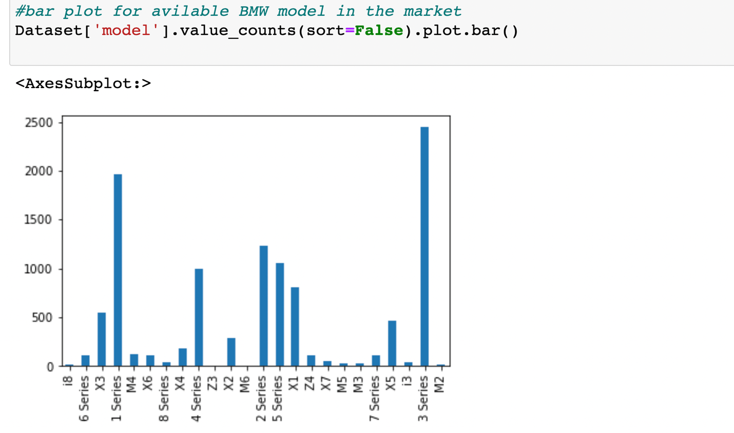

By visualizing the bar plot, It seems that the 3 Series and 1 Series are the most common models among the BMWs.

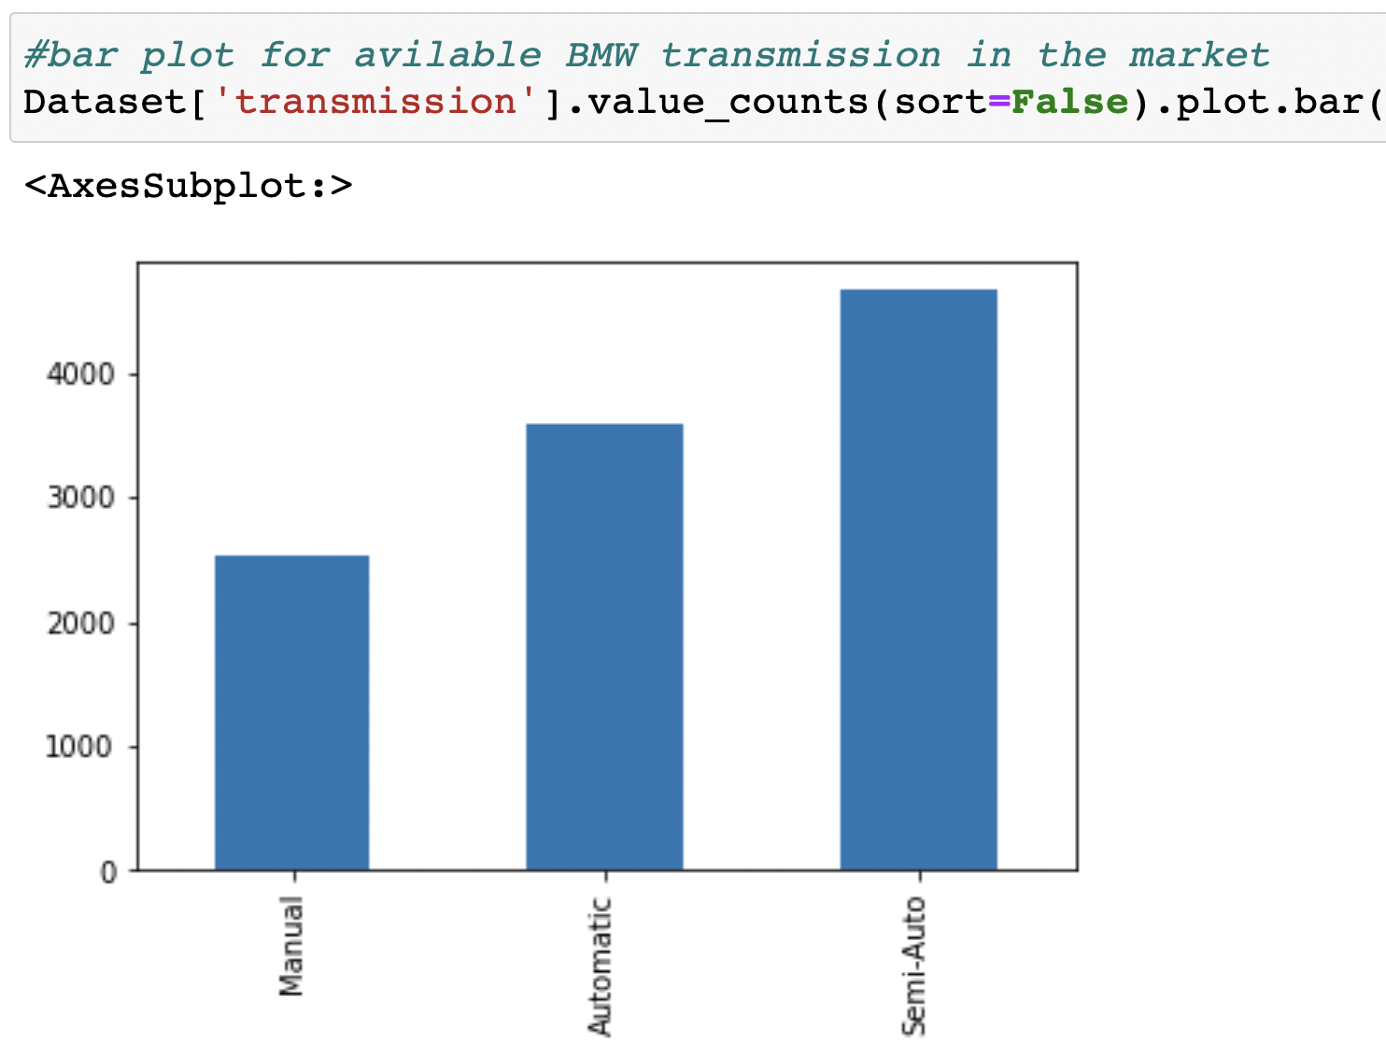

Manual, Automatic and semi-Automatic types of transmission system is available in the dataset. By visualizing the bar plot, It seems that the Automatic and semi-Automatic are the most common transmission system among the BMWs.

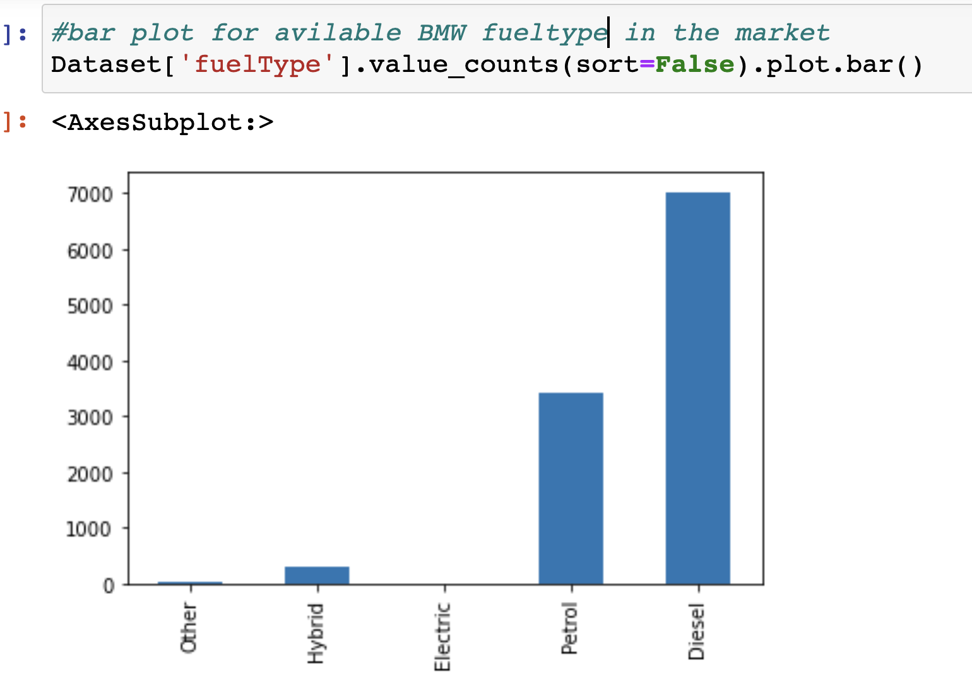

The fuel types used by the BMWs are diesel, petrol, hybrid and electric. By visualizing the bar plot, It seems that the petrol and diesel are the most common fuel types among the BMWs.

**Ordinal Encoder:**

Now we are converting these, 3 categorical columns into numerical columns by ordinal encoder in sklearn.

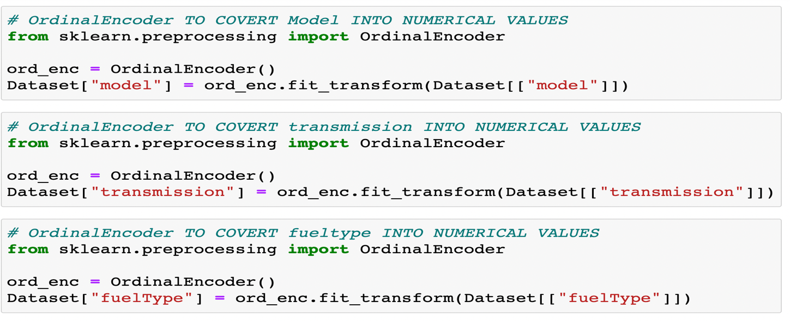

This is the head of the dataset after converting categorical columns into numerical columns.

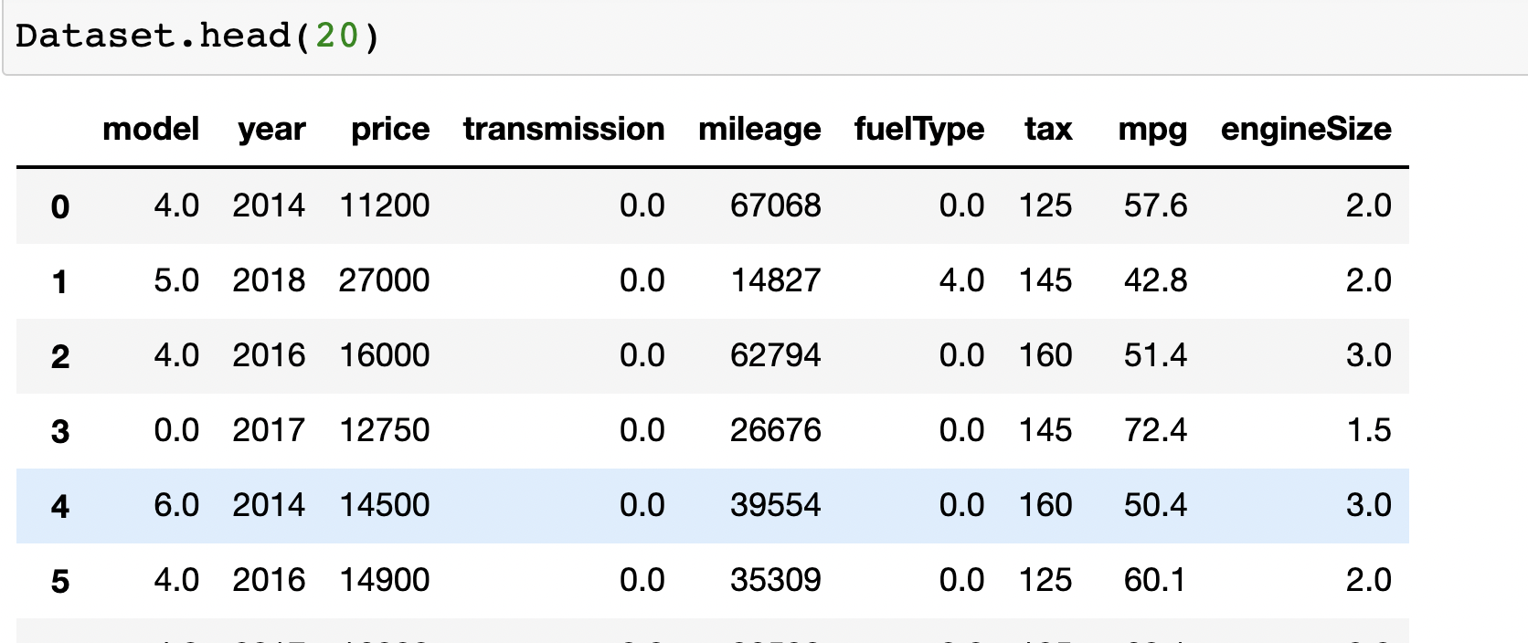

**Data cleaning:**

First step for data cleaning was to remove duplicate rows from the data. In this dataset, number of duplicate rows are 179. So we removed these duplicate rows by drop_duplicates() and after removing these duplicate rows we have 10664 rows and 9 features.

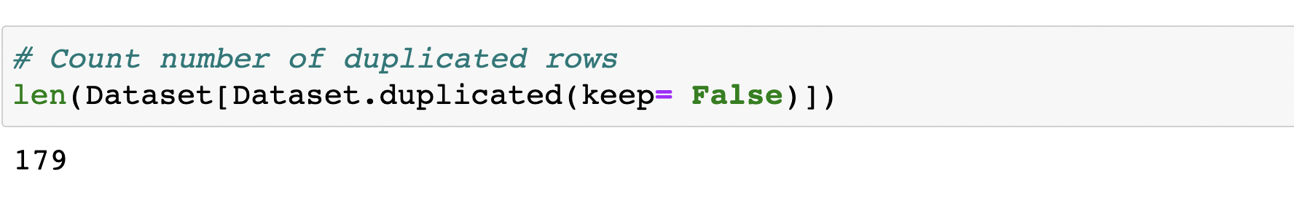

As the second step, we need to check for missing values were filled with appropriate values. But in this dataset, there is no missing value.

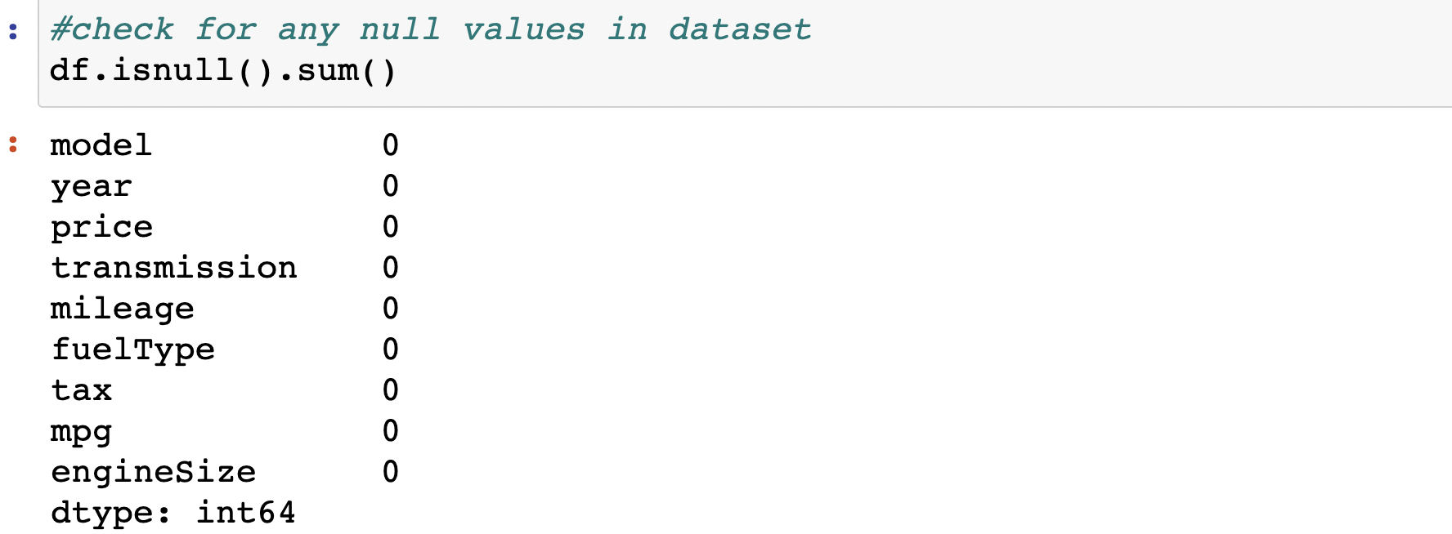

As a next step, we are checking for outliers in the dataset by histogram and box-whisker plots and extreme values were dropped because they inhibit prediction power of the model. There were only three data points greater then 178987 in the mileage column so they are outliers. In year column the data from 1995 to 2000 are outlier because our maximum data fall into the range of 2010 to 2020. In price column, price greater then 99950 are outliers. In mpg values greater then 400 and less then 8 are outlier. In addition, engine size has outliers as well. These values were also dropped from data-set because these are noise for the data. In addition, model transmission and fuel type have no outlier.

At the end of this process, we remove all duplicate rows, missing values and outliers and now the dataset is clean and we have 9799 rows and 9 features.

**Graph to detect outlier in each feature**

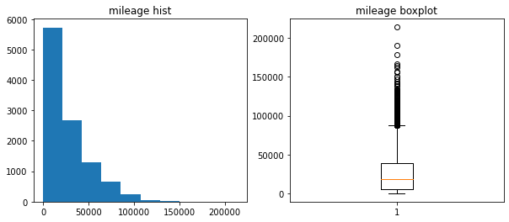

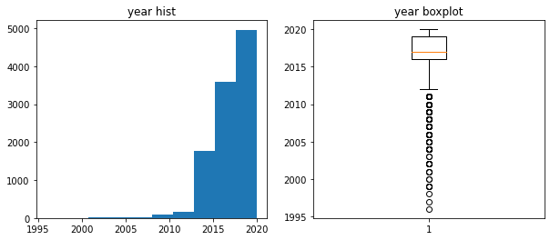

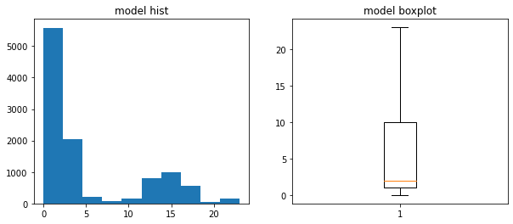

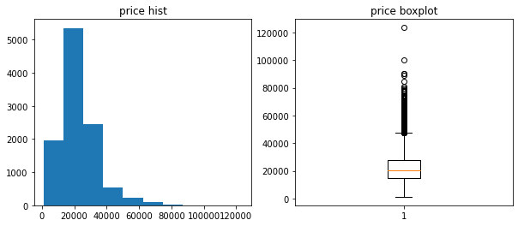

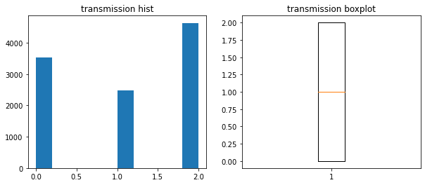

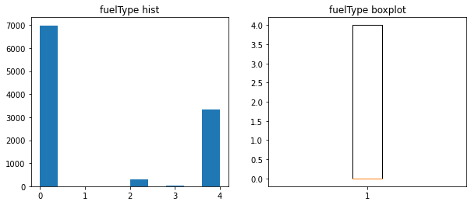

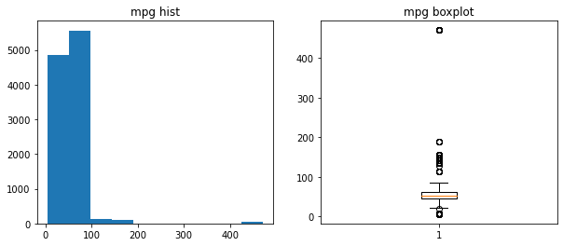

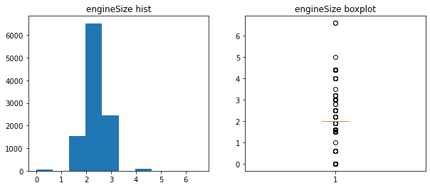

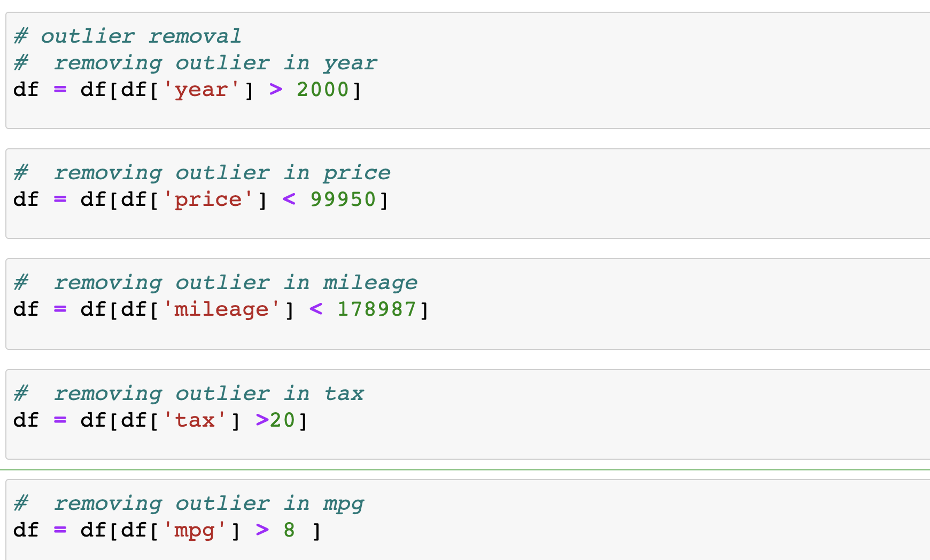

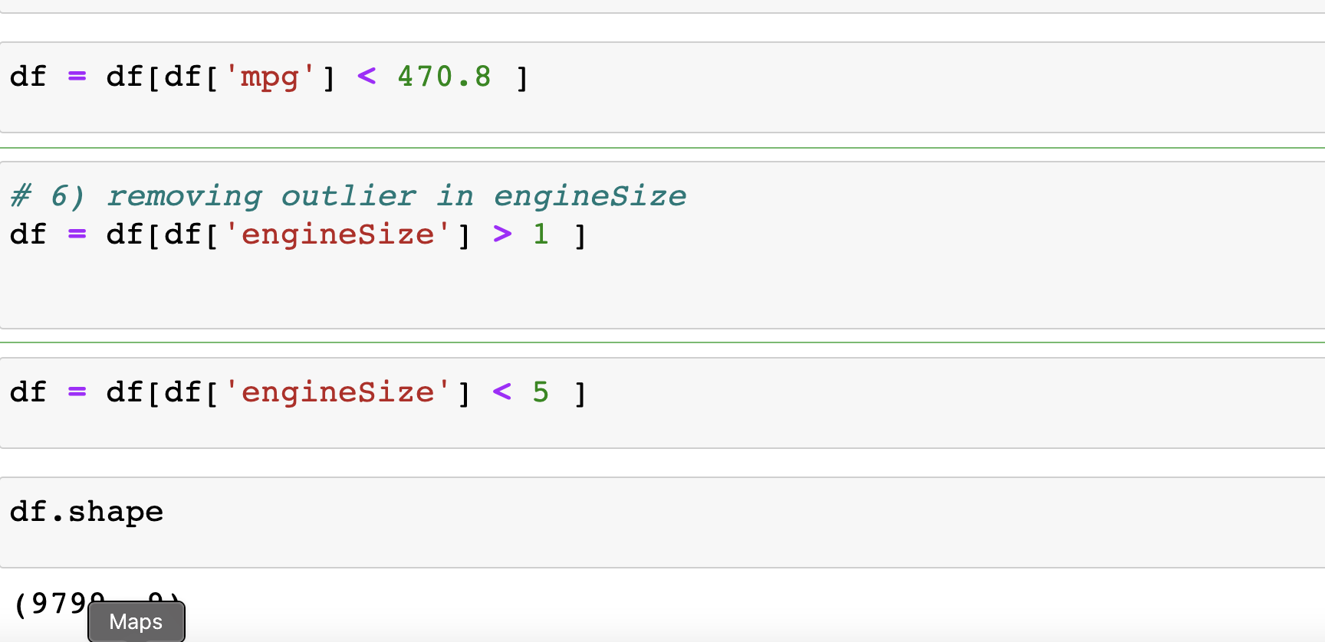

**Box and whisker plot with cleaned dataset:**

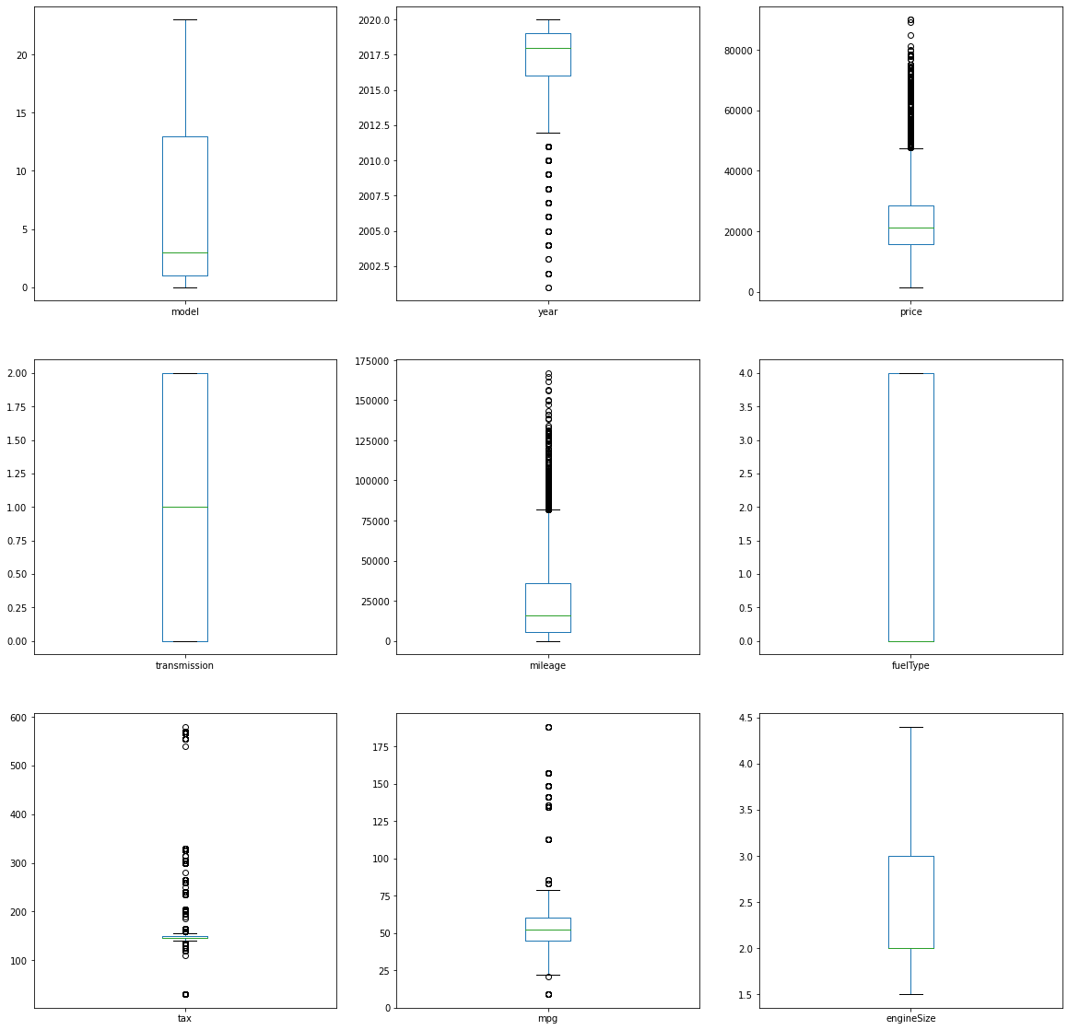

By visualizing above plot, we could see that there are still few outliers remain in the dataset but it is not ideal to remove them because it might affect the prediction model.

**Histogram with cleaned dataset:**

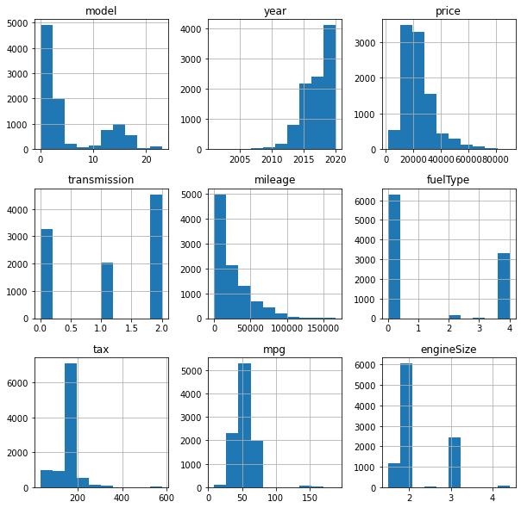

From above histogram plots we could visualize that: -

1. Transmission, engine size and fuel type have a random distribution because lacks an apparent pattern and has several peaks. In a random distribution histogram, it can be the case that different data properties were combined. Therefore, the data should be separated and analyzed separately.
2. Model, mileage, tax and mpg have a right-skewed distribution is also called a positively skewed distribution. In a right-skewed distribution, a large number of data values occur on the left side with a fewer number of data values on the right side. A right-skewed distribution usually occurs when the data has a range boundary on the left-hand side of the histogram. For example, a boundary of 0.
3. Year has a left-skewed distribution, is also called a negatively skewed distribution. In a left-skewed distribution, a large number of data values occur on the right side with a fewer number of data values on the left side. A right-skewed distribution usually occurs when the data has a range boundary on the right-hand side of the histogram.
4. Price has a normal distribution, points on one side of the [average](https://corporatefinanceinstitute.com/resources/excel/functions/average-excel-function/) are as likely to occur as on the other side of the average. Price has a unimodal distribution.

**Density plot with cleaned dataset:**

Density Plot is showing the same information as the histogram.

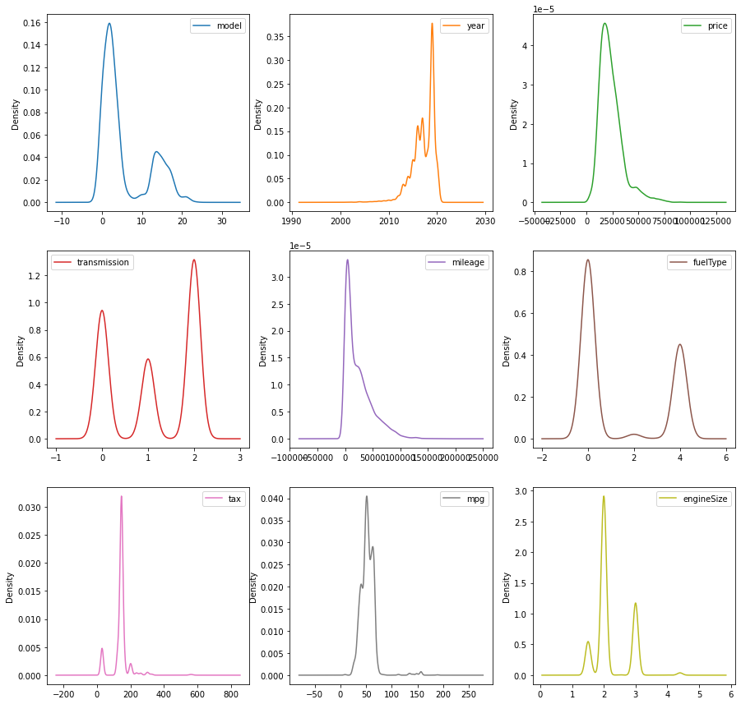

**Scatter matrix plot with cleaned dataset:**

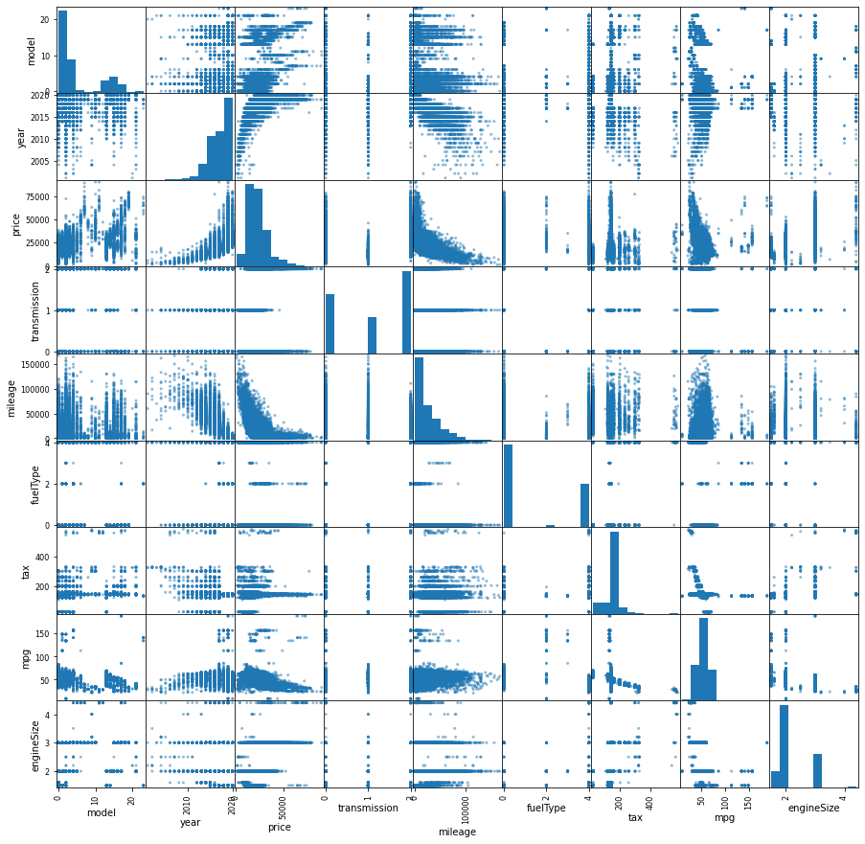

From the above scatter matrix plot the following information can be derived.

1. Price & Year have a direct connection -- maybe the older car has the less price.
2. Price & model are also correlated. -- better model, more the price.
3. Price & tax are also having some correlation -- less price thus lower tax has to be paid.
4. Engine Size & tax are also correlated and indirectly affect the price.
5. Price and mileage are also correlated—maybe the higher mileage of the car have lesser price.

**Feature engineering:**

# **Correlation matrix plot:**

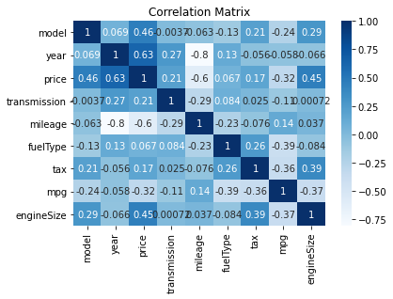

From the above correlationmatrix plot the following information can be derived.

1. Price & Year have a direct connection -- maybe the older car has the less price.
2. Year & mileage are also correlated. – maybe more the year more will be mileage.
3. Price and mileage are also correlated—maybe the higher mileage of the car have lesser price.
4. Miles per gallon (mpg) and tax seem not significant correlate to price.

**# Extra tree classifier**

Furthermore, we used Extra tree classifier to get the best features from the available features. We found that mpg, year, tax, model and mileage are the best features which plays vital role in building the price predication model.

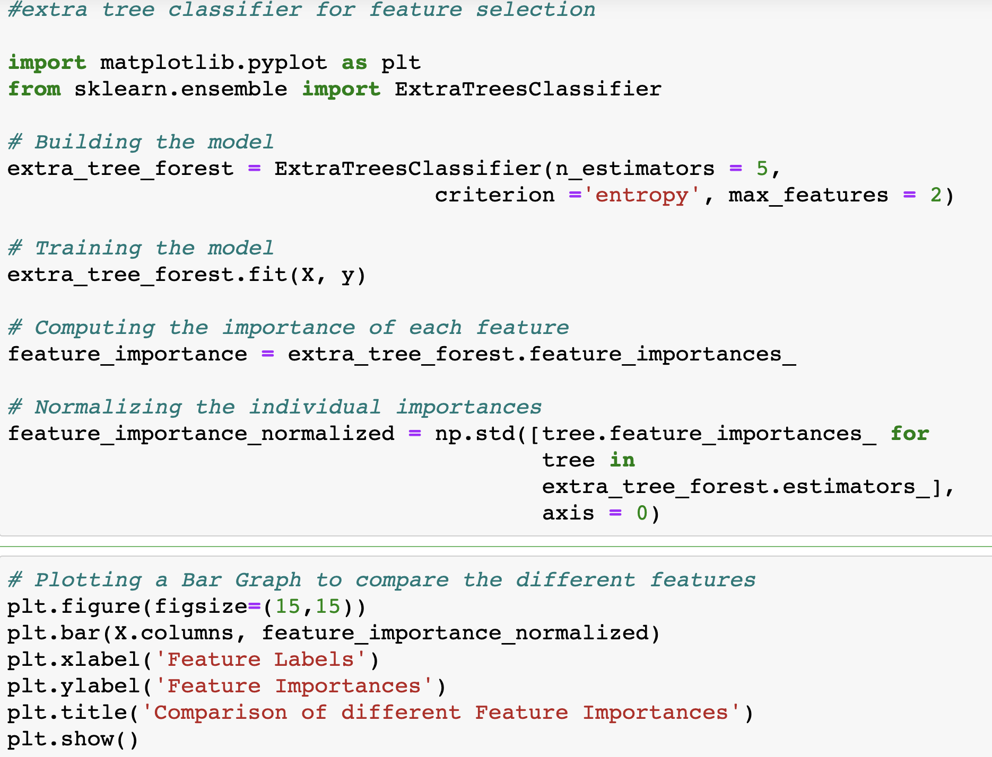

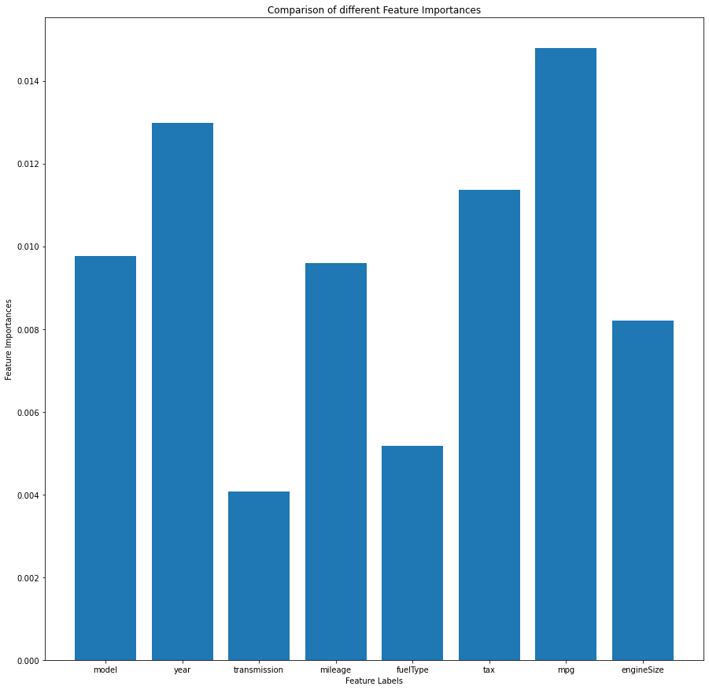

**# Principal component analysis:**

Firstly, we are splitting the dataset in to ‘X’ and ‘y’. In ‘X’ we include every feature except price. In ‘y’ we include only price.

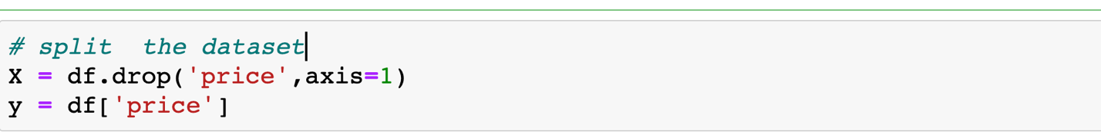

After splitting the dataset, we perform standardisation on the dataset. The price column was dropped to keep a realistic output (price) after scaling the input (features).

### Standardisation

The result of **standardization** (or **Z-score normalization**) is that the features will be rescaled to ensure the mean and the standard deviation to be 0 and 1, respectively. The equation is shown below:

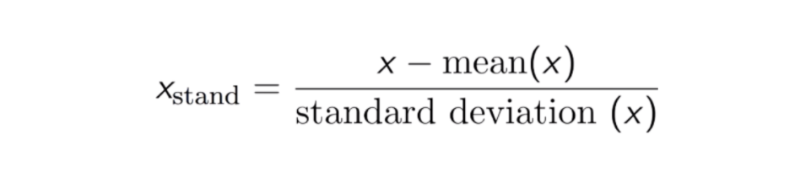

This technique is to re-scale features value with the distribution value between 0 and 1.

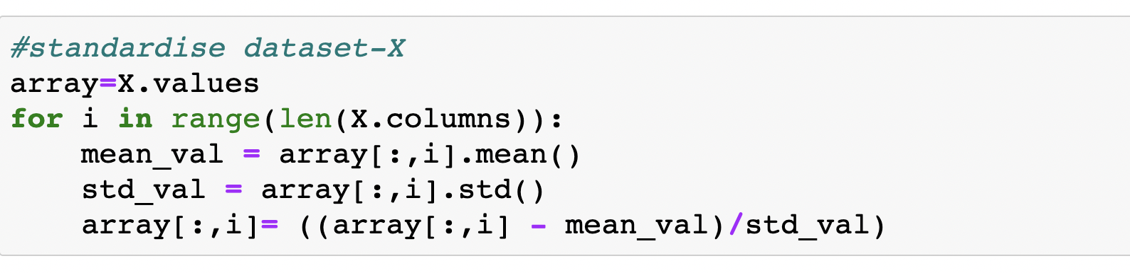



Furthermore, we are going to perform principal component analysis with three features.

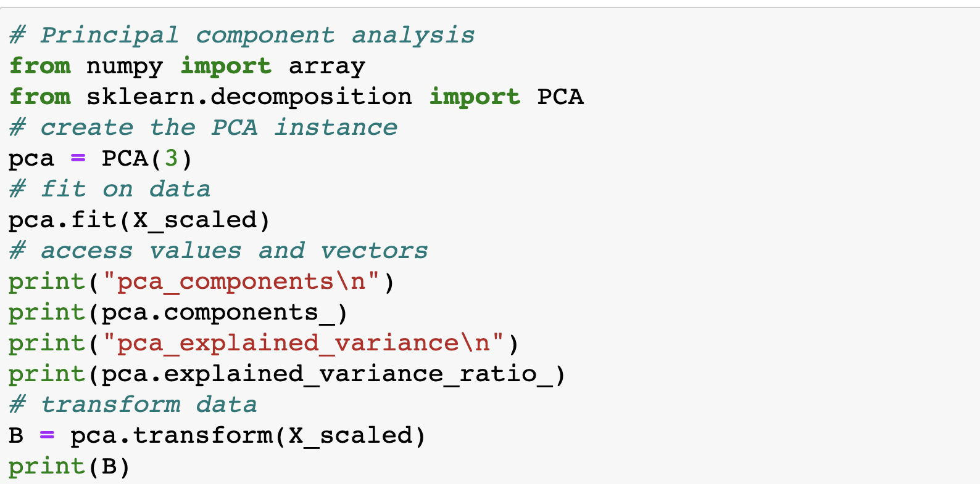

**Output from the PCA:**

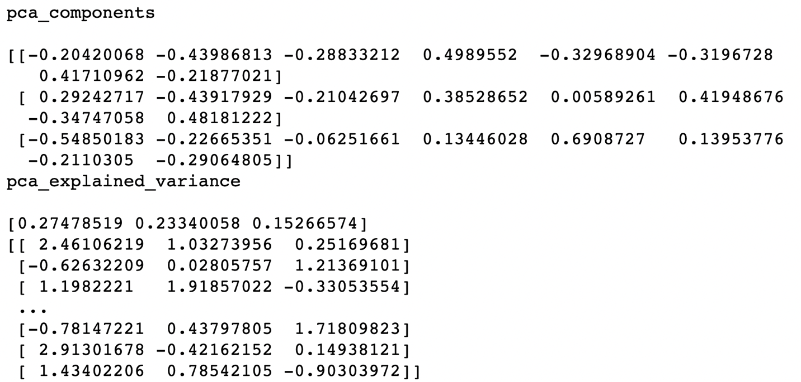

**Machine learning model development:**

After having explored the dataset and the relationship between the variables, it has been decided to proceed with the creation of a predictive model that would be able to identify the car features that mostly influence the price of a used car and then predict its price.

The following steps have been performed for the dataset (in order to give a better overview of the code, screenshots from the dataset will be displayed).

* Importing all the machine learning modules from sklearn machine learning library.

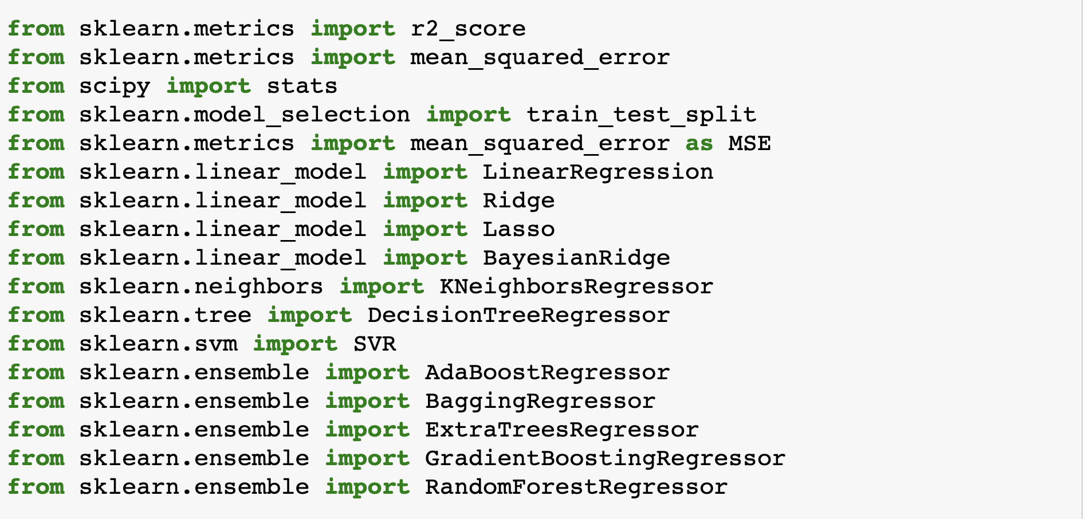

### Standardisation of the dataset





● Splitting the dataset into training and testing datasets. 80% of the dataset was used for training the model and 20% for testing the model for prediction. Random state of 42 was taken.



* We have used the following regression models- Ridge, Lasso, Bayesian ridge, K neighbors regressor, Decision tree regressor, Ada boost regressor, Bagging Regressor, Extra Trees Regressor and Random Forest Regressor and calculated r2-score

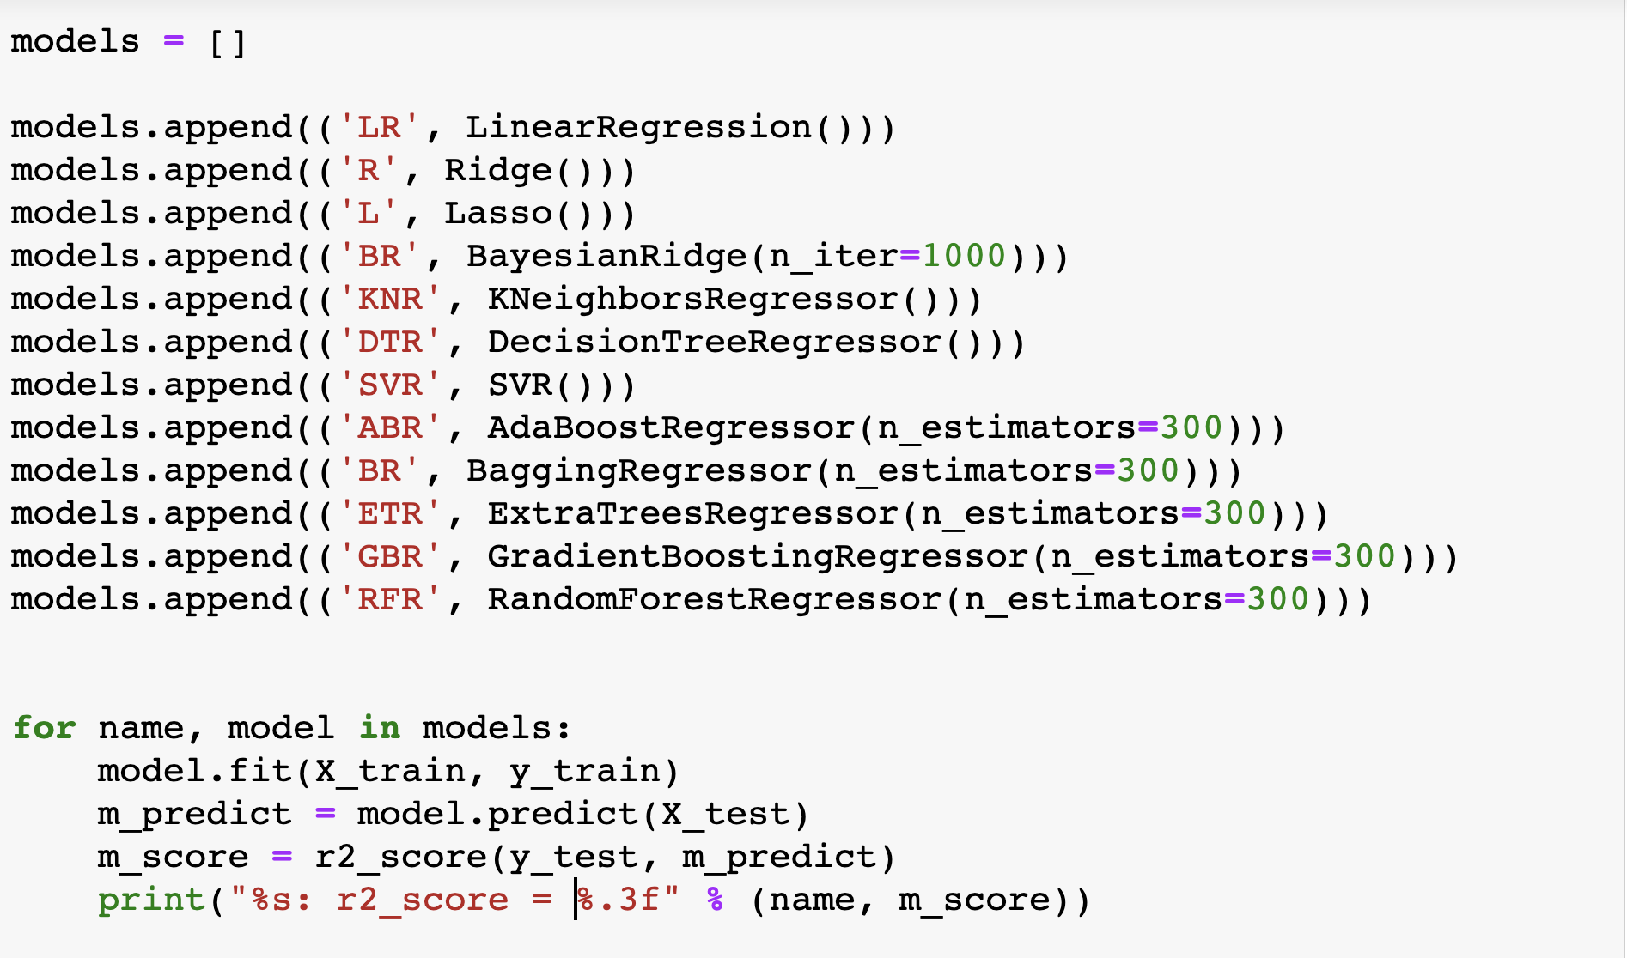

Based on the regression models we have the following R2 score after the standardization of the original dataset.

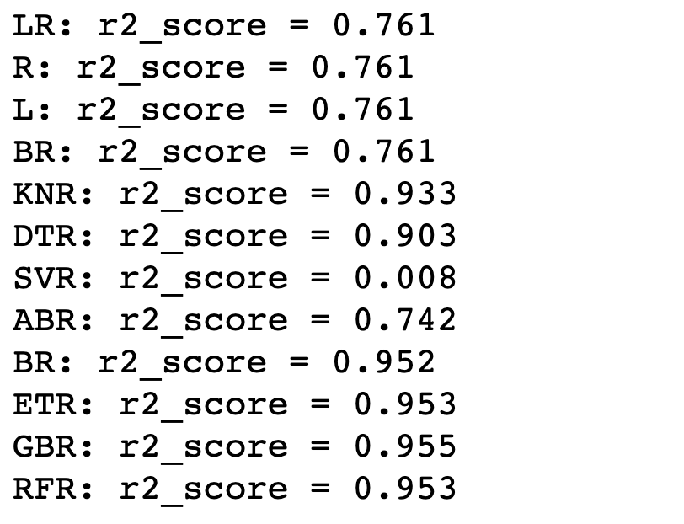

**# Plotting a bar graph to compare the R2_score from different models**

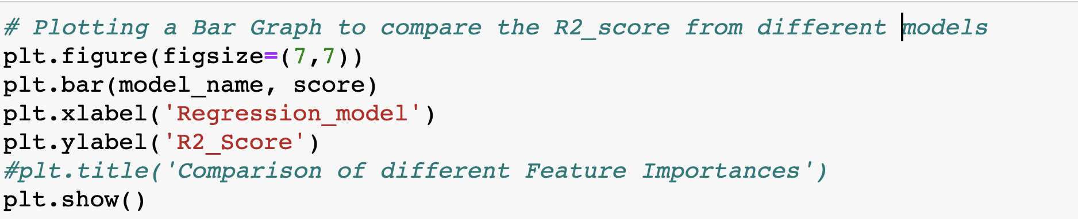

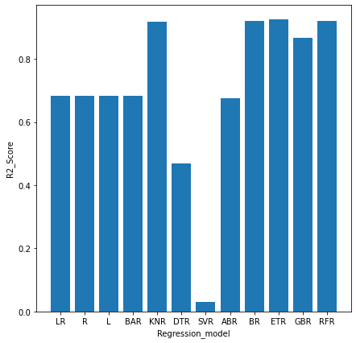

* By visualizing this bar plot we found that K neighbors regressor, Bayesian ridge, Extra Trees Regressor and Random Forest Regressor have highest r2-score.

**# Root mean square error on standardize dataset:**

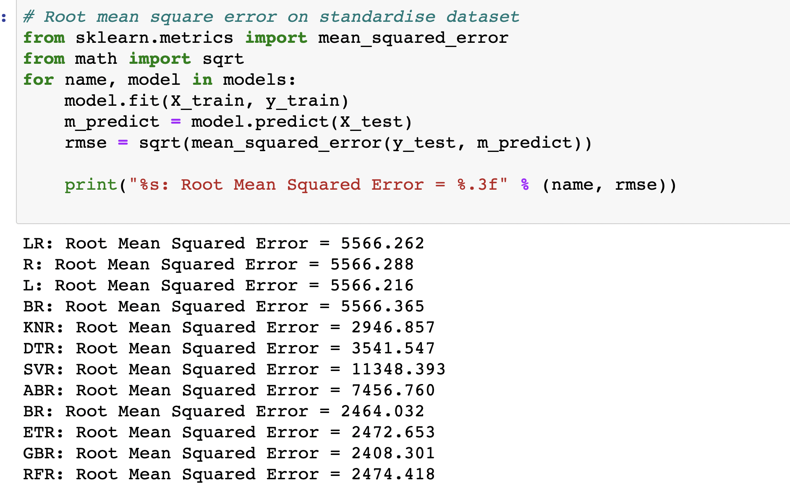

* The RMSE for the extra tree regressor is much smaller. We therefore go with it. It also has a good R2 value on the test dataset.

**# Regression models after applying PCA on standardized dataset:**

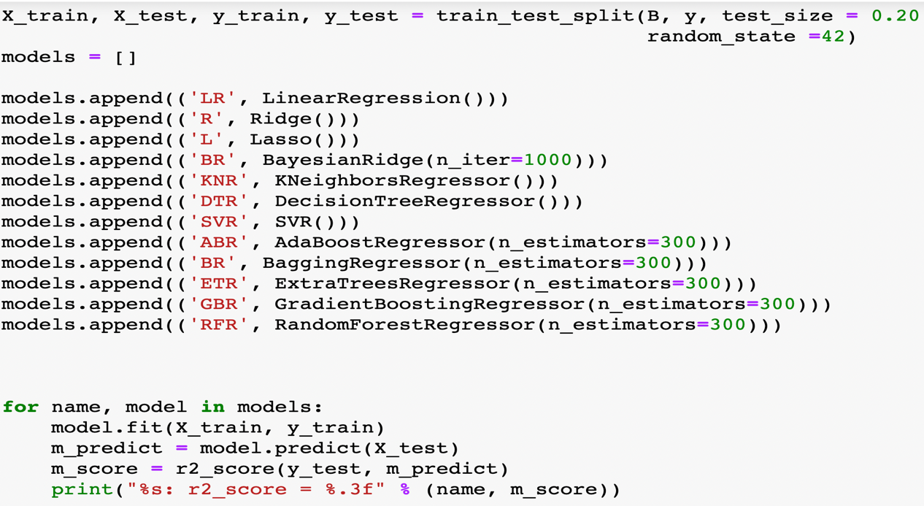

Based on the regression model we have the following R2 score after applying PCA on standardized dataset.

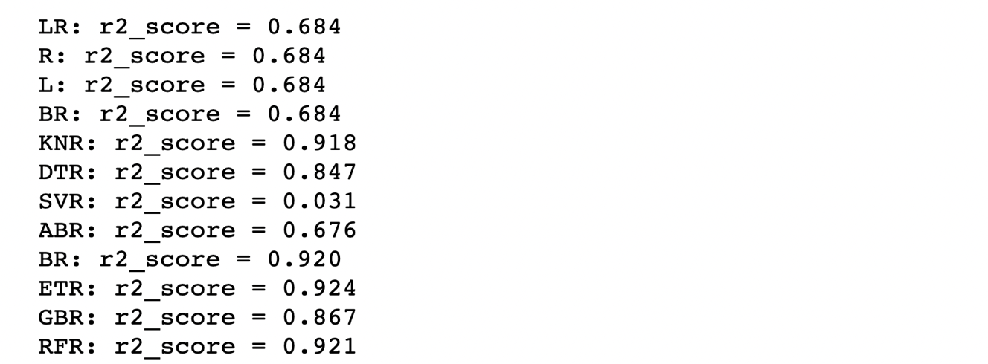

**# Plotting a bar graph to compare the R2_score from different models**

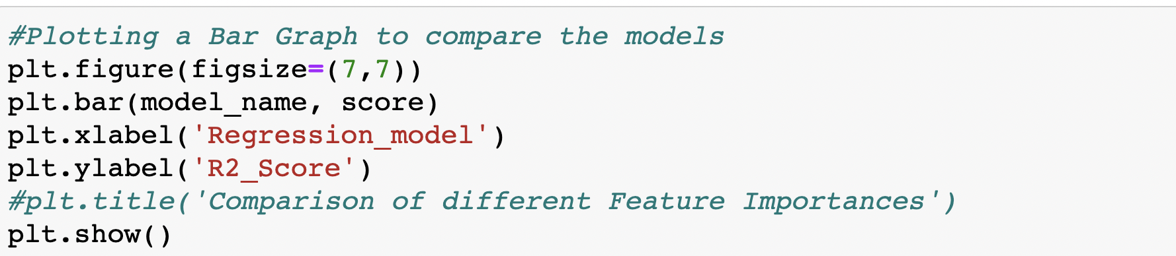



* By visualizing this bar plot we found that K neighbors regressor, Bayesian ridge, Extra Trees Regressor and Random Forest Regressor have highest r2-score.

**# Root mean square error after PCA on standardize dataset:**

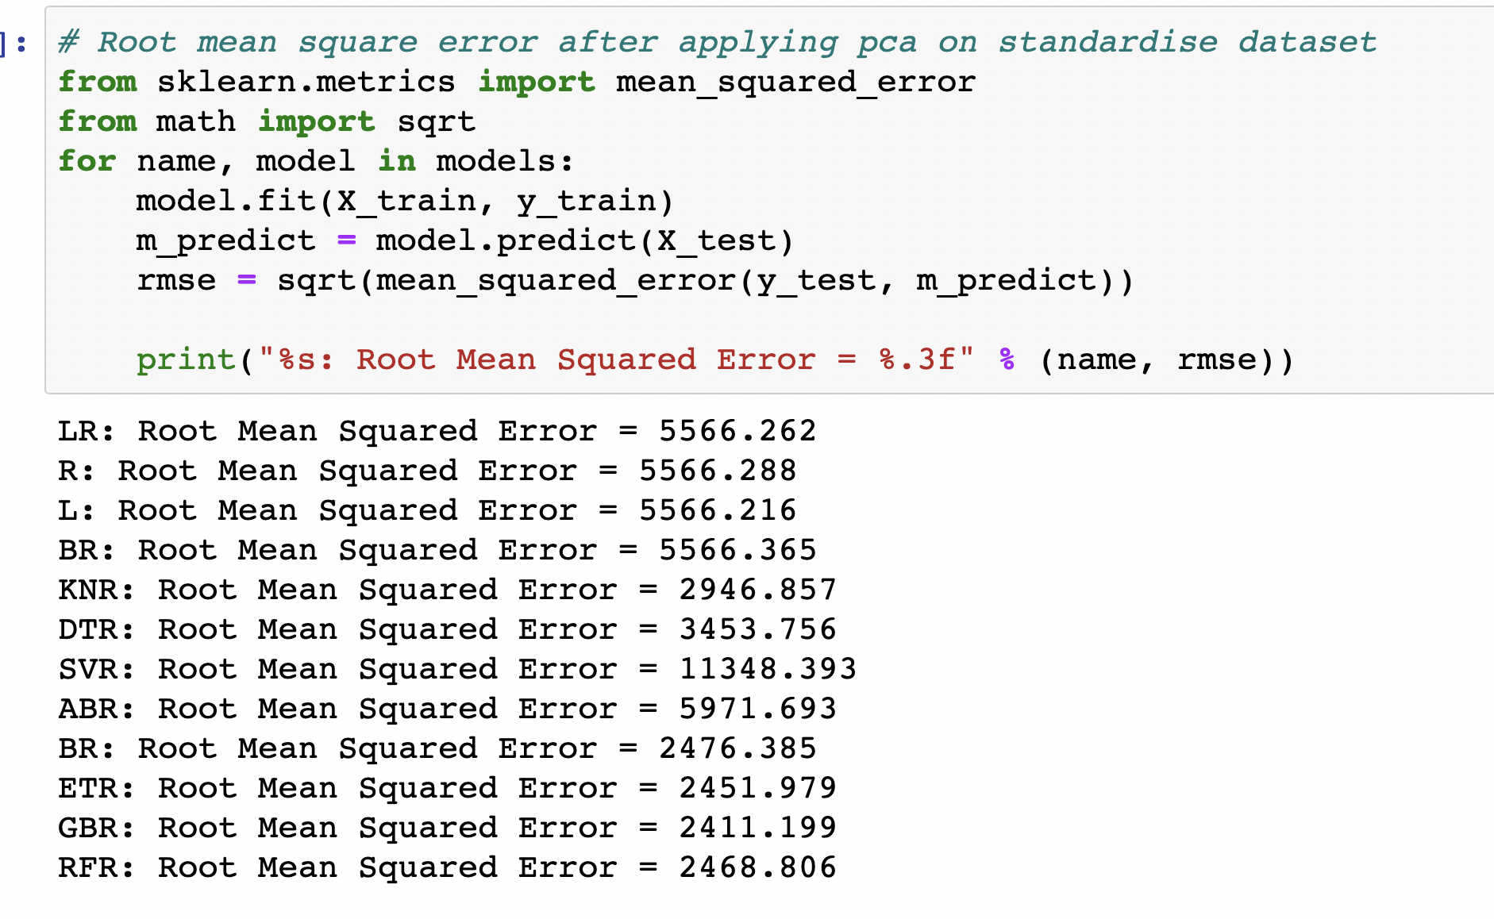

The RMSE for the extra tree regressor is much smaller even after PCA. We therefore go with it. It also has a good R2 value on the test dataset.

We found that before PCA and after PCA among all twelve models Extra tree regressor have the highest R2 score and the smallest root mean square error that’s why we build the predication model using extra tree regressor.

**# Predication model using Extra tree regressor:**

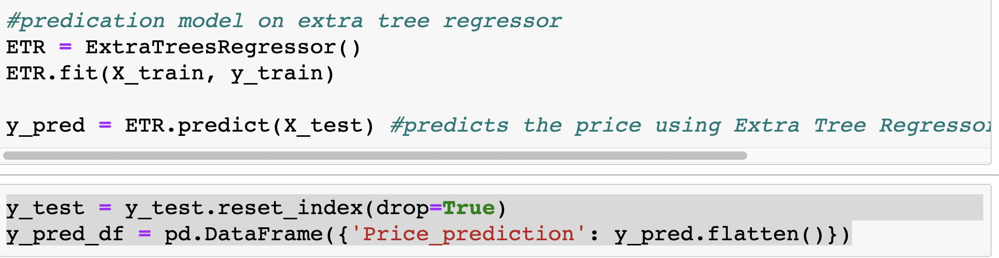

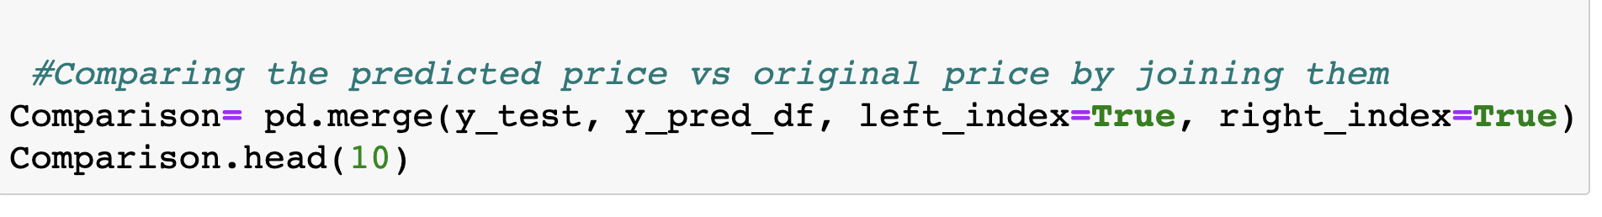

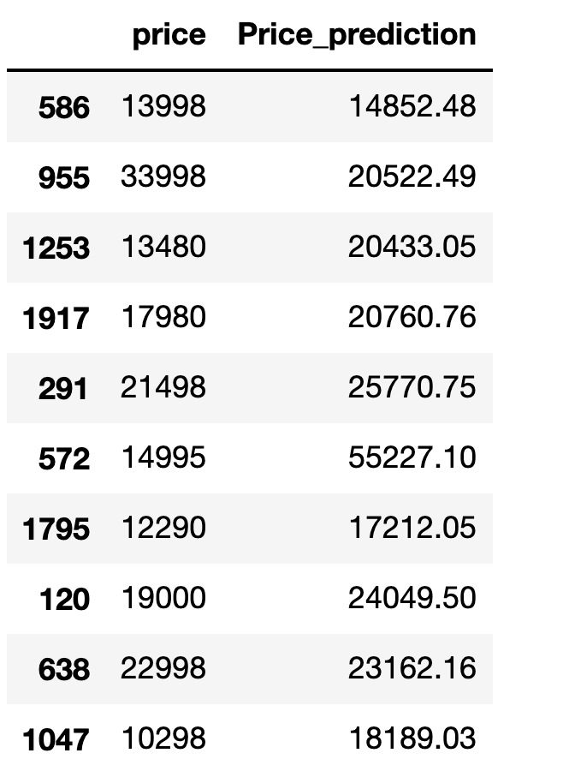

**# Bar plot for predicated price and given price:**

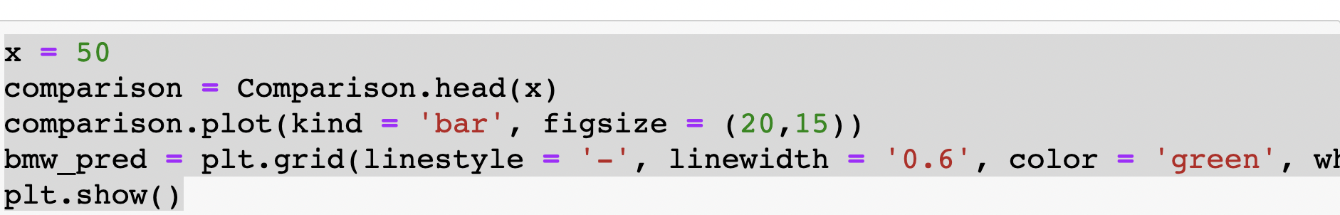

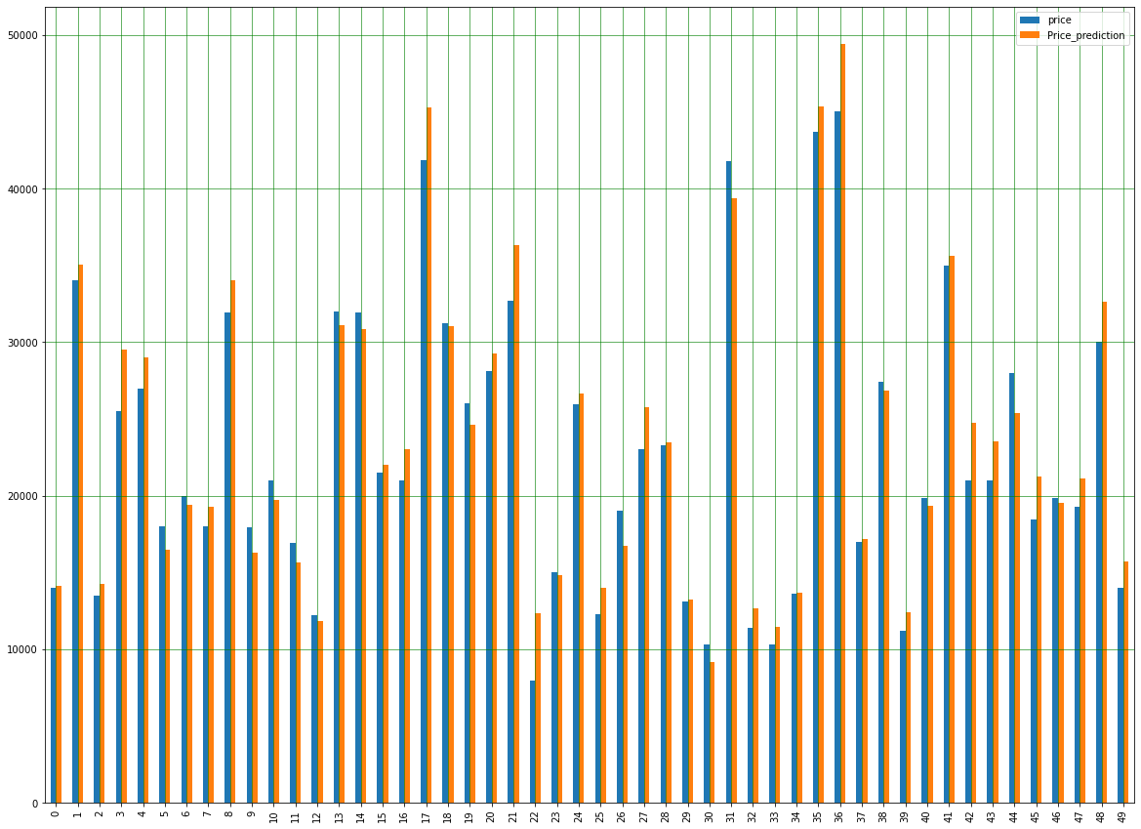

**Results:**

1. Our results from the regression model shows that the R2 score before PCA have good results compared to R2 score after PCA so we build our prediction model on R2 score after the standardization of the original dataset. We used twelve model to predict the R2 score and out of those we found that extra tree regressor and random forest regressor have the more then 90% accuracy. So, we choose extra tree regressor to build the prediction model and we found that predicated price of used car is somewhat similar to given price.
2. Our results from scatter matrix plot shows that the Price & Year have a direct connection -- maybe the older car has the less price. Year & mileage are also correlated– maybe more the year more will be mileage.
3. Our results from Extra trees classifier shows that mpg, year, tax, model and mileage are the best features which plays vital role in building the price predication model.

**Conclusion:**

Car price prediction can be a challenging task due to the high number of attributes that should be considered for the accurate prediction. The major step in the prediction process is collection and preprocessing of the data. In this research, dataset is standardized and cleaned to avoid unnecessary noise for machine learning algorithms. Data cleaning is one of the processes that increases prediction performance, yet insufficient for the cases of complex data sets. In this paper, twelve different machine learning techniques have been used to forecast the price of used cars in UK. Among all the regression model, extra tree regression gives us more than 92% accuracy before and after PCA that why we have chosen extra tree regression to build the predication model. From the prediction model we concluded that the predicated price is somewhat similar to the actual price.

The main limitation of this study is the low number of records that have been used. As future work, we intend to collect more data and to use more advanced techniques like artificial neural networks, fuzzy logic and genetic algorithms to predict car prices.

**Appendix:**

**# code to plot histogram and box plot**

import matplotlib.pyplot as plt

def plots(df,col):

fig, ax = plt.subplots(1, 2, figsize=(10,4))

ax[0].hist(df[col])

ax[0].set_title(col + ' hist')

ax[1].boxplot(df[col])

ax[1].set_title(col + ' boxplot')

plt.show()

**# box plot after removol of outlier**

df.plot(kind='box', subplots=True, layout=(3,3), sharex=False, sharey=False,figsize=(20,20))

plt.show()

**# histogram with cleaned dataset**

import matplotlib.pyplot as plt

df.hist(figsize=(10,10))

plt.show()

**# density plot with cleaned dataset**

df.plot(kind='density', subplots=True, layout=(3,3), figsize=[15,15], sharex=False)

plt.show()

**# scatter matrix plot with cleaned dataset**

from pandas.plotting import scatter_matrix

scatter_matrix(df,figsize=[15,15])

plt.show()